SmartBiz Pro ERP
Funding Proposal & Full Project Plan
Date: 2026-01-13
Document Version: 2.0
Prepared for: Investors / Donors / Strategic Partners
Prepared by: SmartBiz Pro Development Team

Table of Contents
1. Executive Summary
2. Problem Statement & Market Gap
3. Solution Overview
4. Product Scope: Modules & Features
5. Predictive Analytics
6. Offline-First Architecture & Conflict Resolution
7. Technical Architecture
8. API Specification Examples
9. Roadmap & Milestones
10. Team & Governance
11. Budget & Use of Funds
12. Appendices (Wireframes)

SmartBiz Pro ERP — Funding Proposal & Full Project Plan

**Document Version:** 2.0
**Date:** 2026-01-13
**Prepared for:** Investors / Donors / Strategic Partners
**Prepared by:** SmartBiz Pro Development Team

1. Executive Summary

SmartBiz Pro is a modern, modular **offline-first ERP** designed for multi-industry SMEs and growing enterprises. It provides end-to-end business management (Finance, Inventory, Procurement, HR/Payroll, Production/Projects) while maintaining **full operational continuity during internet outages**.

**Funding ask (baseline):** **USD $235,750** for a 10-month build (6–8 core team), plus go-to-market pilot costs.

2. Problem Statement & Market Gap

2.1 Key pain points in existing ERP solutions
- **Connectivity dependence:** Cloud-only ERPs degrade when internet fails; frontline operations stall (POS, warehouse, field teams).
- **High integration complexity:** Data compatibility, customization, and integration costs remain key barriers.
- **Implementation failure risk:** Many ERP programs run over budget/timeline due to change management, data migration, training, and scope creep.

2.2 Opportunity
SmartBiz Pro targets the underserved segment of businesses that need:
- Reliable operations **offline** for extended periods
- Local compliance (VAT/PAYE and audit controls)
- Faster deployment via industry templates
- Actionable insights (predictive analytics) rather than static reports

3. Solution Overview (SmartBiz Pro)

3.1 Core Value Proposition
1. **Offline-first** transaction processing with robust sync and conflict resolution
2. **Composable modular ERP**: deploy only what you need; scale as you grow
3. **Industry Quick-Start Templates**: go-live in hours, not weeks
4. **Predictive Analytics**: business health score, forecasts, anomaly alerts
5. **API-first platform**: integrations with payments, banks, eCommerce, SMS/WhatsApp

3.2 Target Industries
Retail/Wholesale, Healthcare/Clinics, Schools/Education, NGOs/Projects, Manufacturing.

4. Product Scope: Modules & Detailed Features

4.1 Production / Project Management
- Multi-project hierarchies and budgets
- Resource allocation, capacity planning, utilization dashboards
- Milestones and Gantt timelines
- Material requirements integrated with Inventory (MRP-lite)
- Collaboration: comments, attachments, mentions

4.2 Stakeholders (Customers/Suppliers)
- Custom fields, segmentation, credit limits, payment terms
- Interaction history and communication logs
- Customer portal: invoices, statements, payments
- Supplier performance scoring (lead time, quality, price variance)
- Bulk import/export

4.3 Budget Management
- Budget codes and hierarchies
- Approval workflows for estimates
- Variance analysis and alerting
- Rolling forecasts and what-if scenarios

4.4 Payroll Management
- Multiple payroll schedules; payslips; bank vouchers
- PAYE, statutory deductions, allowances & benefits
- Loans and advances
- Year-end certificates
- Electronic distribution (email/SMS)

4.5 Store / Inventory Management
- GRN automation; stock ledger movements (append-only)
- FIFO/LIFO/Weighted valuation
- Barcode scanning; batch/expiry
- Multi-location & transfers
- Cycle counts and audit trails
- Reorder automation + forecasts

4.6 Account / Cash Management
- Multi-account statements; transfers; petty cash
- Bank reconciliation; cashflow forecasting
- Multi-currency support
- Audit trail and financial ratio dashboards

4.7 Purchases Management
- Requisition → approvals → PO → GRN → invoice (3-way match)
- VAT computation, spending analytics
- Contract & price list management

4.8 HR Management
- Employee records + document storage
- Leave workflows; attendance/time tracking
- Performance appraisals; training records
- Org chart and recruitment workflow

4.9 Dashboards & Analytics
- Executive dashboard with KPIs
- Custom report builder
- Scheduled reports
- Predictive insights embedded in workflows

4.10 System Administration
- RBAC, permissions templates
- Audit logging, activity monitoring
- Backup & recovery, configuration

5. Predictive Analytics: How It Enhances ERP Value

SmartBiz Pro upgrades ERP from **recording** to **advising**.

5.1 High-ROI Predictive Use Cases
- **Cash runway & cashflow forecast** (7/30/90 days)
- **AR late-payment risk** scoring per customer
- **Stockout prediction** and reorder recommendations
- **Budget overrun prediction** based on burn rate
- **Anomaly detection** for fraud/leakage (stock adjustments, duplicate payments)

5.2 Delivery Strategy (Phased)
- **Phase A (MVP):** rules + moving averages + SQL-based forecasts
- **Phase B:** lightweight ML scoring service (risk/churn)
- **Phase C:** anomaly detection + recommendation engine

6. Offline-First Architecture & Conflict Resolution

6.1 Client-side Offline Components
- Service Worker caching + background sync
- IndexedDB (Dexie) as local database
- Local outbox queue (operations log)
- Sync engine (push/pull + prioritization)
- Conflict resolution UI for manual review

6.2 Conflict Resolution Strategy
Not all data conflicts are equal:
- **Finance (invoices/payments/ledger):** no silent merges; manual review
- **Inventory:** event-based append-only stock movements merge safely
- **Master data:** field-level merge with safeguards

6.3 Key Mechanisms
- **Idempotency keys** per operation to prevent duplicates
- **Optimistic concurrency control** using record versioning
- **Conflict records** stored and surfaced to users

6.4 Simplified Sync Pseudocode
async function syncOfflineChanges() {
// 1. Connectivity check
if (!navigator.onLine) return;
// 2. Prioritized queue
const ops = await db.outbox
.where('status').equals('PENDING')
.sortBy('priority');
const batch = ops.slice(0, 200);
// 3. Push operations (idempotency keys)
const res = await api.post('/sync/push', {
deviceId,
operations: batch
});
// 4. Mark synced + store conflicts
for (const ok of res.applied) {
await db.outbox.update(ok.operationId, { status: 'SYNCED' });
}
for (const c of res.conflicts) {
await db.outbox.update(c.operationId, { status: 'CONFLICT' });
await db.conflicts.put(c);
}
// 5. Pull latest server changes
await pullLatestChanges();
}

7. Technical Architecture

7.1 High-level Architecture
Client (PWA/Mobile/Desktop)
- Next.js PWA, Service Worker
- IndexedDB + Sync Engine
|
| HTTPS/WebSocket
v
API Gateway (Hono on Bun)
- Auth, RBAC, Rate-limits
- OpenAPI docs, webhooks
|
v
Services (modular)
- Finance, Inventory, HR/Payroll, Projects, Reporting
|
v
Supabase (Postgres + Auth + Realtime + Storage)
- RLS policies
- Audit logs

7.2 Technology Stack
- **Frontend:** Next.js (React), Tailwind, shadcn/ui, React Query, Zustand
- **Offline:** Dexie (IndexedDB), Service Worker, background sync
- **Backend:** Bun runtime + Hono, Zod, Drizzle ORM, Pino logging
- **Database:** Supabase Postgres + RLS; Redis cache; object storage
- **DevOps:** Docker, GitHub Actions, Kubernetes (prod), Prometheus/Grafana, Sentry

8. API Specification (Examples)

8.1 REST Endpoints (sample)
openapi: 3.0.3
info:
title: SmartBiz Pro API
version: 1.0.0
paths:
/auth/login:
post:
summary: Login
/inventory/items:
get:
summary: List items
post:
summary: Create item
/inventory/stock-movements:
post:
summary: Create stock movement (GRN/SALE/ADJUST)
/finance/invoices:
get:
summary: List invoices
post:
summary: Create invoice
/sync/push:
post:
summary: Push offline operations
/sync/pull:
get:
summary: Pull server changes since cursor

9. Roadmap & Milestones (10 Months)

Phase 1 (Weeks 1–8): Foundation
- Setup monorepo, CI/CD, environments
- Auth + RBAC + tenanting
- Offline engine v1 + sync logs
- UI framework + dashboard skeleton

Phase 2 (Weeks 9–20): Financial Core
- Stakeholders + Budgets
- Cash/Bank + Purchases
- Store/Inventory (offline-first)

Phase 3 (Weeks 21–32): HR & Advanced
- HR + Payroll compliance
- Production/Projects
- Cross-module integration tests

Phase 4 (Weeks 33–40): Industry packs + Polish
- Templates for 3 industries
- Predictive analytics v1
- Security audit + performance optimization

10. Team & Governance
- PM (1), Tech Lead (1), FE (2), BE (2), DevOps (1), QA (1)
- Agile 2-week sprints, demo every sprint
- Change-control board to prevent scope creep

11. Budget & Use of Funds (Baseline)

| Category | Total (USD) |
|---|---:|
| Personnel (10 months, 6–8 team) | 190,000 |
| Infrastructure | 10,000 |
| Tools & Services | 5,000 |
| Contingency (15%) | 30,750 |
| **Grand Total** | **235,750** |

12. Appendices

A. Wireframes
- `wireframe_dashboard.png`
- `wireframe_pos.png`
- `wireframe_inventory.png`
- `wireframe_conflicts.png`

Appendix: Wireframes

Executive Dashboard
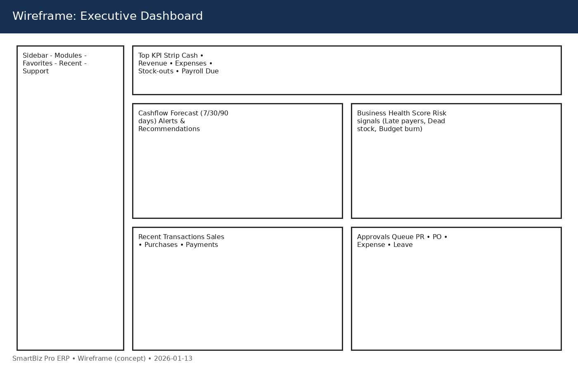

Retail POS
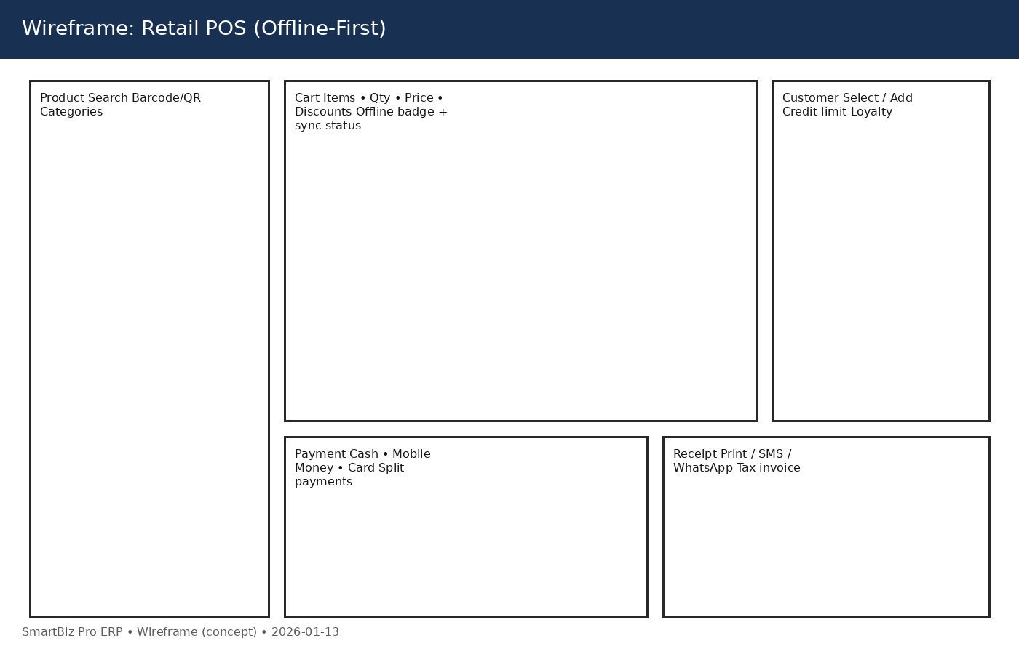

Store & Inventory
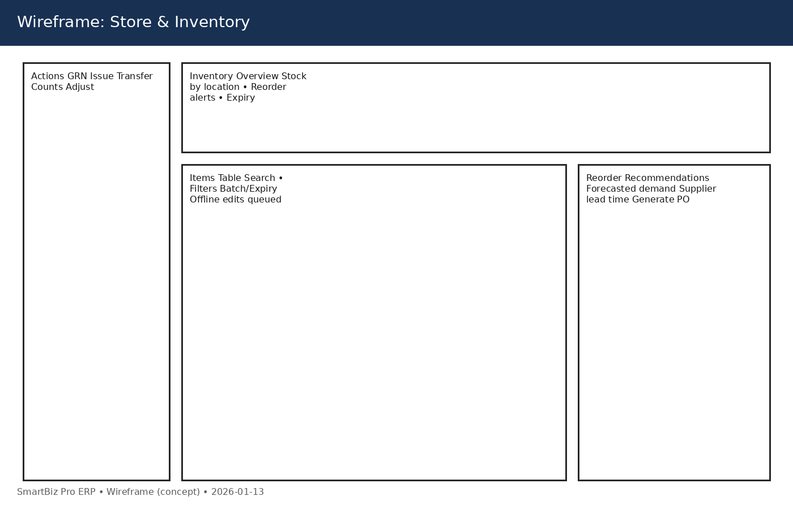

Conflict Resolution
